Cross-beam fruit press
VP-20s
Using Guide

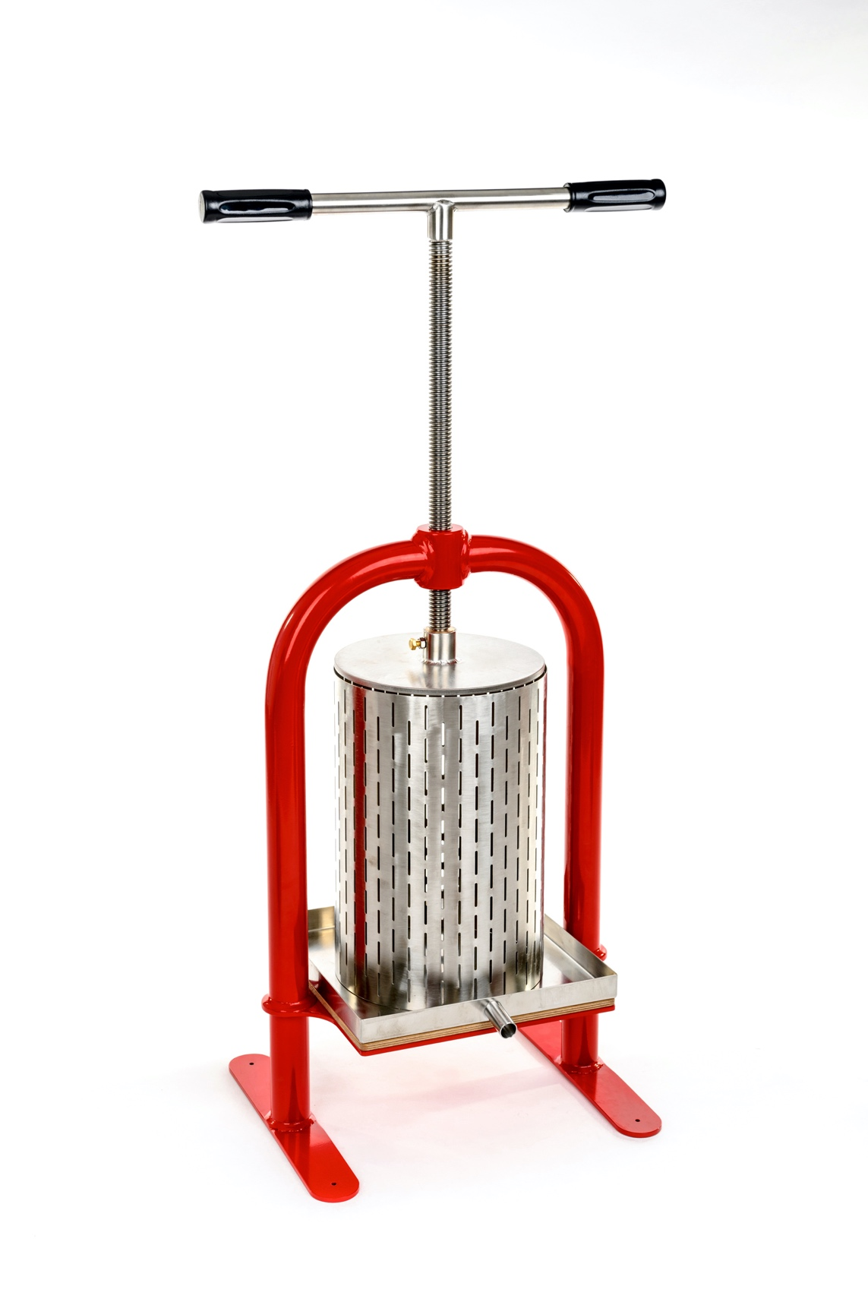

Dear customer!
This guide will help you to learn how to use the press effectively. Check the complete set, items listed in the table №1, the absence of external and mechanical damage when making a purchase.

ATTENTION!
Before you start using the press read this guide carefully, please. Owing to the constant improvement of the device, the company keeps the right to make some changes in the design and look of the press. This may possibly cause some differences between purchased good and its description and illustration.

1. General guidelines
1.1 Cross-beam fruit press VP-20s (hereinafter referred to as "press") is meant for apple, pear, berry, grape, vegetable, etc. juice extraction in personal agricultures and small farms.
1.2 Press is designed for use indoors or under the shelter at the temperature from 0 ° C to + 40 ° C.
1.3 During the exploitation and storage prevent any falls and bumps.

2. Presses VP-20s complete set

Complete set item | Amount (pcs.)
Frame | 1
Screw | 1
Drain pan (tray) | 1
Basket (barrel) | 1
Piston | 1
Filtration fabric | 1

3. Presses VP-20s technical characteristics

Basket’s capacity: | 20 L
Basket’s height: | 390 mm
Basket’s diameter: | 256 mm
Weight: | 28 kg
Dimensions: | 39х46х80 cm

Parts of the press which get in contact with the juice are made of oak and alimentary stainless steel.

4. Safety measures
Follow safety measures using this device. Violation of manual and safety measures may lead to accidents.

ATTENTION!
4.1. The device during the work must be securely fixed on a massive table, a bench or the floor using the screws or clamps (there are special holes for this in the legs of press).
4.2. Do not hold on the working part of the screw when the lever is rotated.
4.3. Do not use any foreign objects working with the press. For example, it is not allowed to put a tube on the screw in order to increase the lever and thereby get a greater force to tighten the screw.
4.4. Avoid foreign objects getting on the screw (e.g. sand or steel shavings).

5. Getting started
5.1. Take the device out of the package. Before the first use of the press rinse the barrel and piston, wash the tray with warm water using a sponge, add some soda or detergent. Rinse thoroughly the filtration fabric.
5.2. Set the device on a flat surface and fix it securely on a massive table, a bench or the floor using the screws or clamps (there are special holes for this in the legs of press). Using a screw press of the small capacity (up to 10 L) it is enough to set the press on the flat surface and hold the frame with your hand when turning the screw.

6. Operating procedure
6.1. Prepare the raw (pulp) for pressing the juice. Apples, pears and vegetables should be chopped into small pieces by a crusher, berries - pound with a wooden masher or mince.
6.2. Set the tray with the barrel on the edge of the table.
6.3. Put the filtration fabric into the basket so that the edges of the fabric would hang behind the walls of the basket. Place a container for juice collecting under the tray. It is necessary since the juice starts exuding even before pressing.
6.4. Fill the basket with pulp, fold the edges of the filtration fabric and cover the pulp evenly.
6.5. Set the tray with the filled basket on the wooden base. Centre the barrel according to the piston.
6.6. Start pressing the juice by turning the screw clockwise. Fasten the screw slowly, so that would be enough time to separate the juice from the pulp.
If you have plenty of time, it is possible to get for 5-10% more juice. For this, turn the screw, when almost no juice released, and leave the press in this position for 5 minutes. Then tighten the screw another half turn and then wait for 5 minutes. Repeat this procedure until the screw turns with little effort after 5 minutes of waiting, and the juice is released.
6.7. Pour off the remains of juice by tilting the press. When the juice is dripped out unscrew the screw so that you can take the tray with the barrel out from the frame.
6.8. Take the filtration fabric with the pomace out of the barrel. To do this, turn the barrel and press on the bag with pomace from above by sliding it down. Then turn the barrel again and pull the bag with pomace out. Pomace can be used to feed animals or for composting.
6.9. Having finished the work rinse thoroughly the barrel, piston, tray and filtration fabric with water without using any detergent. Having washed these parts wipe them dry and let them to get completely dry in the sun.

Watch how to work with press on our website or YouTube channel:
https://www.youtube.com/channel/UCKFdbuOASzI3aWwq2rgMoBA/videos

Approximate amount of juice:
From the juicy apples, depending on the variety and ripeness, collected from the apple tree: 50-70%
From the apples collected from the ground or stale apples: 20-40%.
Therefore, it is better to make the juice of apples freshly picked from the tree. In this way you will get as much juice as possible with the highest amount of vitamins. You will save more time on washing apples (it may take most of the time, especially if you need to sort them and trim the damaged areas). Moreover, you save the necessary fermentation, natural yeast. It is good if you are going to do wine from the juice. Such juice is much tasty and healthy.

How to store the juice for winter:
- In glass jars;
Squeeze the juice using the press for apples. Pour it into the pan. If the juice is too sour you may add some sugar. Heat it to 70-80 ° C and leave it heating for 5 minutes. Then pour the juice into sterile jars and roll up with sterile lids. Turn the jar upside down and wrap it up. Leave to cool.

- Bag in Box;
It is possible to store the juice using the bag in box system: fill the plastic bag with hot pasteurized juice and place it in a cardboard box.

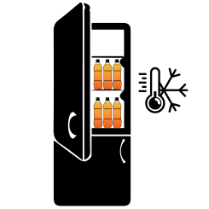
- Freeze;
It is very convenient to freeze the juice in conventional plastic bottles, if the size of your freezer allows it. Just pour the juice into bottles and put them in the freezer. In this case you do not need to spend time on pasteurization; the juice retains 80-90% of vitamins and retains its original taste (as if it is just squeezed). Pasteurized juice has slightly different taste, it changes owing to heating.

More information about juice storage for winter read on our website. There you may also find a variety of apple recipes and useful articles about care of your garden.

7. Maintenance
7.1. From time to time lubricate the screw, thrust bearing and bronze bushing using lithium base grease (e.g. Texaco Multifak EP 2).
7.2. If the filtration fabric has deteriorated you may use any other fabric intended for contact with food. For example, lavsan or linen fabric. You need to cut a piece of fabric of the desired size and coverstitch the edges on the sewing machine.

8. Storage rules
Store the press in a dry place, avoiding the contact with precipitations and direct sunlight.

9. Manufacturer's warranty
9.1 The manufacturer guarantees good work of the device if the rules of governing storage, installation and operation mentioned in the using guide are observed.
9.2 The warranty period for the device is determined by the manufacturer and it lasts for 36 months from the date of sale to the customer. If the date of purchase is not mentioned, the warranty period is counted from the date when the device was manufactured.
9.3 The manufacturer guarantees free repairs during the warranty period if the following conditions are met:
- the device was used strictly according to the using guide, otherwise the repair is paid by the customer;
- a positive decision of examination carried out by the commission of experts in the quality department within one month from the date of receiving the device back;
- the device was received clean, without any mechanical damage, and fully equipped;
- customer’s application specifying the reasons of breaking down, photos or videos;
- technically justified act of the trading organization.
9.4 The manufacturer's warranty excludes the following cases:
- the origin of a defect in an intentional and mistaken actions of the customer;
- the damage or breaking down of the device owing to natural disasters;
- the damage caused by ingress of extraneous items, objects, liquids;
- the damage caused by the direct or indirect effect of mechanical forces, chemical, thermal or physical coercion;
- disassembly, modification and other interventions which are not provided in the using guide.

Manufacturer:
SIA «Apple Press Ltd»
Registration number: 40203130458
VAT number: LV40203130458
Address: Maskavas iela 260K-1-13, Riga, LV-1063, Latvia

