Juice pasteurizer SP-98
Using Guide

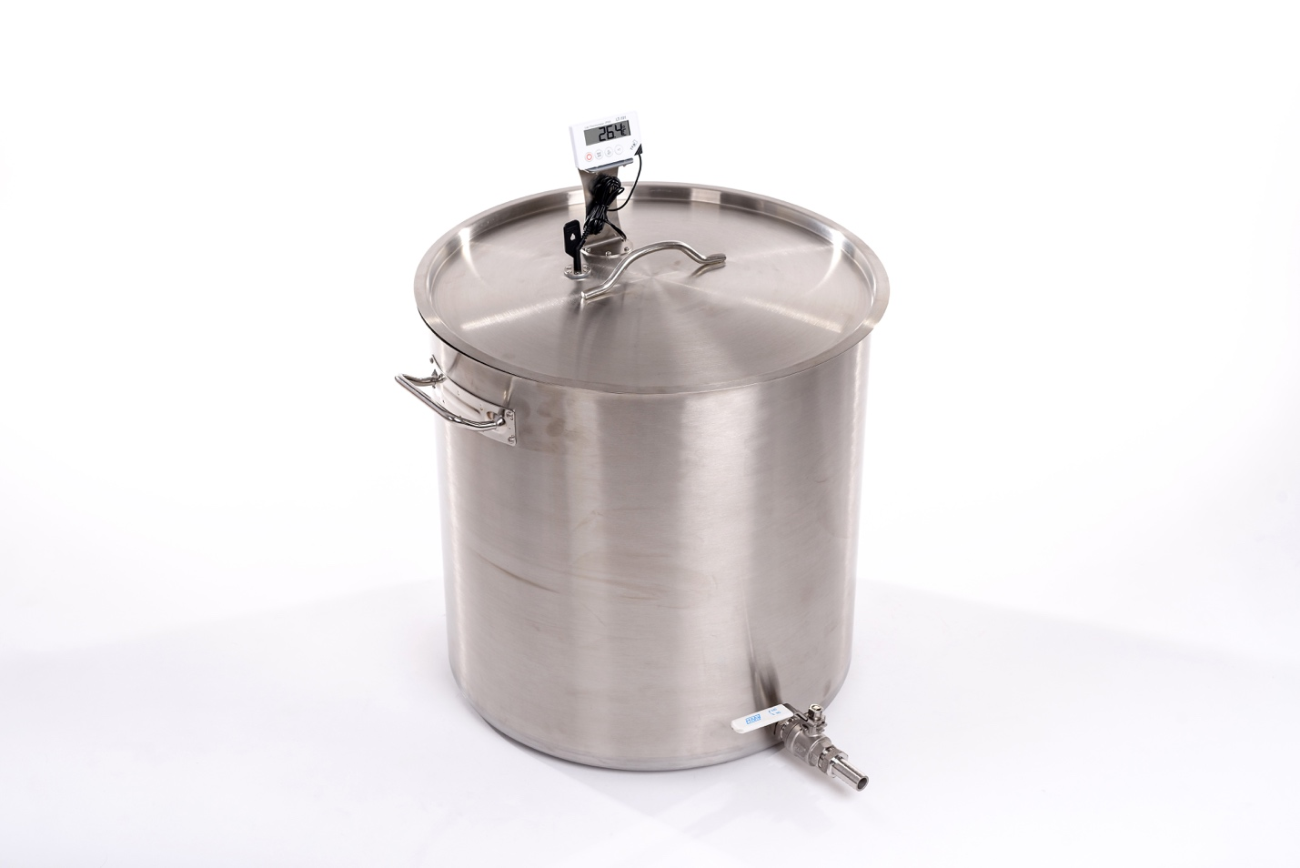

Dear customer!
This manual will help you learn how to use the pasteurizer effectively.
When buying, check the scope of supply specified in Table 1, the absence of visible and mechanical defects.

ATTENTION!
Please read this manual carefully before using the pasteurizer.
Due to the continuous improvement of the product, the company reserves the right to make individual changes in its design and appearance, which may cause differences between the purchased product and its description or the image in the figure.

1. General guidance
1.1 Juice pasteurizer SP-98 (hereinafter referred to as the “pasteurizer”) is designed for pasteurization of fruit and berry juices in personal agricultures and small farms.
1.2 The pasteurizer is designed to operate indoors or under shelter at ambient temperatures from 0°C to plus 40°C.
1.3 During the exploitation and storage prevent any falls and bumps.

2. Juice pasteurizer SP-98 - list of equipment and configuration

Component | Quantity (pcs.)
Pasteurizer | 1

3. Juice pasteurizer SP-98 - specification

Productivity: | Over 100 l/hour
Heating element type: | Ceramic, electric, gas, induction
Dimensions: | 50х50х55 cm
Weight: | 17 kg
Material: | Food grade stainless steel
Thermometer type: | Electronic

4. Safety measures
Follow safety measures using this device. Violation of using guidelines and safety measures may lead to accidents.

ATTENTION!
Set the pasteurizer on the activated heating element only if you have the sufficient fluid amount (at least 20-40 liters of juice).
4.1 Use only as intended for juice pasteurization.
4.2 Keep minors under 16 from using the pasteurizer. Keep the pasteurizer out of reach of children.
4.3 When working with the pasteurizer, pay close attention to the safety of persons in the operating area of the appliance.
4.4 Turn on the heating element with the pasteurizer installed only after you check the level of juice and the safe installation of all structural elements.
4.5 Do not use the unit under rain in the open area.
4.6 Disassemble and rinse the pasteurizer only after removing it from the heating element.
4.7 Under no conditions can the housing of the pasteurizer thermometer be wet. Make sure that the juice does not make contact with the thermometer.
4.8 Before starting work, install the pasteurizer in a safe place on a hard and flat surface. It must be positioned in a stable way.
4.9 The pasteurizer must be used only in an upright position.
4.10 The pasteurizer can be moved only when it is empty and has cooled to room temperature.
4.11 Do not tilt the pasteurizer when it is based on a working heating element.
4.12 Do not touch the pasteurizer with bare hands and do not open the lid during operation until the equipment has cooled. Otherwise, you can get a burn or burned with steam.

5. Preparation for work
5.1 Remove the product from its packaging. The pasteurizer is disassembled for transportation.
5.2 Place the product on a flat surface, such as a table.
5.3 Insert the tap into the hole at the bottom of the pan. Put a silicone gasket on the end of the tap end protruding on the inside of the pan, then put the washer on the gasket and screw manually with a nut. Make sure the handle of the tap is in the horizontal position. After that, tighten the nut with a 34 mm wrench, holding the tap itself in the correct position.
5.4 Place the thermometer bracket on the lid of the pasteurizer and secure it with the 4 screws supplied with the pasteurizer.
5.5 Insert the thermometer probe into a special hole on the lid of the pasteurizer.
5.6 Make sure that the pasteurizer tap is in the closed position.
5.7 Before the first use rinse the pasteurizer pan with water. Pour a few liters of water into the pasteurizer pan, open the filling tap and let the water drain. Thus it is possible to wash the inner cavity of the tap. Wipe the pasteurizer lid with a damp cloth. Wipe the pasteurizer with a damp cloth and let it dry.

6. Operating procedure.
6.1 Place the pasteurizer on the heating element. The pasteurizer must be positioned in a stable way.
6.2 Pull the thermometer probe out of the lid and remove the lid.
6.3 Pour up to 95 litres of juice into the pasteurizer. Cover the pasteurizer with the lid and insert the pasteurizer probe into the lid hole. Make sure that the pasteurizer probe is immersed in the juice at least 1-2 cm (this will ensure the accuracy of the thermometer calculations).
6.4 Turn on the thermometer and set it to a maximum temperature of 80 °C. Thus, the thermometer will beep when the desired temperature of the juice pasteurization is achieved.
6.5 Switch on the heating element.
6.6 After the set pasteurization temperature of the juice has been reached, turn off the thermometer or turn off the beep, set the heating element to the minimum power and keep the juice at 80 °C for 10 minutes. Turn off the heating element or leave the heating element at minimum power.
6.7 The pasteurized juice can be poured with a tap at the bottom of the pasteurizer. For ease of use, you can put a silicone tube of the required length on the nipple of the tap. The silicone tube should be fit for contact with food and for juice pasteurization temperature.
6.8 For gravity filling of the juice, the end of the silicone hose must be below the juice level in the pasteurizer.
6.9 You can also connect the nipple of the pasteurizer tap to the Bag in Box filler (which has a locking tap or a filling pistol) with a silicone tube suitable for contact with food and the pasteurization temperature of the juice.
6.10 To make the juice enter the juice filler, the pasteurizer must be 0.5-1m above the filler. You can also use an electric pump designed for hot juice by connecting it between the nipple of the pasteurizer tap and the bag filler.
6.11 After there is no more juice in the pasteurizer, set the tap handle to the closed position. Pour a new portion of the juice, set the heating element at the required power and turn on the thermometer.
6.12 After using the pasteurizer, turn off the heating element, turn off the thermometer. Let the pasteurizer cool down.
6.13 Rinse the pasteurizer pan with water. Pour a few liters of water into the pasteurizer pan, open the filling tap and let the water drain. Thus it is possible to wash the inner cavity of the tap. Wipe the pasteurizer lid with a damp cloth. Wipe the pasteurizer with a damp cloth and let it dry.

Watch the video of the pasteurizer operation on the pasteurizer page of our website or on our YouTube channel: https://www.youtube.com/channel/UCKFdbuOASzI3aWwq2rgMoBA/videos

Approximate amount of juice:
From the juicy apples, depending on the variety and ripeness, collected from the apple tree: 50-70%
From the apples collected from the ground or stale apples: 20-40%.
Therefore, it is better to make the juice of apples freshly picked from the tree. In this way you will get as much juice as possible with the highest amount of vitamins. You will save more time on washing apples (it may take most of the time, especially if you need to sort them and trim the damaged areas). Moreover, you save the necessary fermentation, natural yeast. It is good if you are going to do wine from the juice. Such juice is much tasty and healthy.

How to store the juice for winter:
- In glass jars;
Squeeze the juice using the press for apples. Pour it into the pan. If the juice is too sour you may add some sugar. Heat it to 70-80 ° C and leave it heating for 5 minutes. Then pour the juice into sterile jars and roll up with sterile lids. Turn the jar upside down and wrap it up. Leave to cool.

- Bag in Box;
It is possible to store the juice using the bag in box system: fill the plastic bag with hot pasteurized juice and place it in a cardboard box.

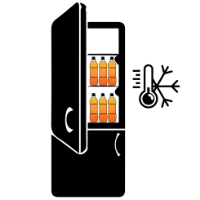
- Freeze;
It is very convenient to freeze the juice in conventional plastic bottles, if the size of your freezer allows it. Just pour the juice into bottles and put them in the freezer. In this case you do not need to spend time on pasteurization; the juice retains 80-90% of vitamins and retains its original taste (as if it is just squeezed). Pasteurized juice has slightly different taste, it changes owing to heating.

More information about juice storage for winter read on our website. There you may also find a variety of apple recipes and useful articles about care of your garden.

7. Maintenance
7.1 If the cutting blade gets blunt, it can be sharpened with a round file or milling metal.

8. Storage rules
Store the crusher in a dry place, avoiding the contact with precipitations and direct sunlight.

9. Manufacturer's warranty
9.1 The manufacturer guarantees good work of the device if the rules of governing storage, installation and operation mentioned in the using guide are observed.
9.2 The warranty period for the device is determined by the manufacturer and it lasts for 36 months from the date of sale to the customer. If the date of purchase is not mentioned, the warranty period is counted from the date when the device was manufactured.
9.3 The manufacturer guarantees free repairs during the warranty period if the following conditions are met:
- the device was used strictly according to the using guide, otherwise the repair is paid by the customer;
- a positive decision of examination carried out by the commission of experts in the quality department within one month from the date of receiving the device back;
- the device was received clean, without any mechanical damage, and fully equipped;
- customer’s application specifying the reasons of breaking down, photos or videos;
- technically justified act of the trading organization.
9.4 The manufacturer's warranty excludes the following cases:
- the origin of a defect in an intentional and mistaken actions of the customer;
- the damage or breaking down of the device owing to natural disasters;
- the damage caused by ingress of extraneous items, objects, liquids;
- the damage caused by the direct or indirect effect of mechanical forces, chemical, thermal or physical coercion;
- disassembly, modification and other interventions which are not provided in the using guide.

Manufacturer:
SIA «Apple Press Ltd»
Registration number: 40203130458
VAT number: LV40203130458
Address: Maskavas iela 260K-1-13, Riga, LV-1063, Latvia

