Bag in Box filler BIBF-20
Using Guide
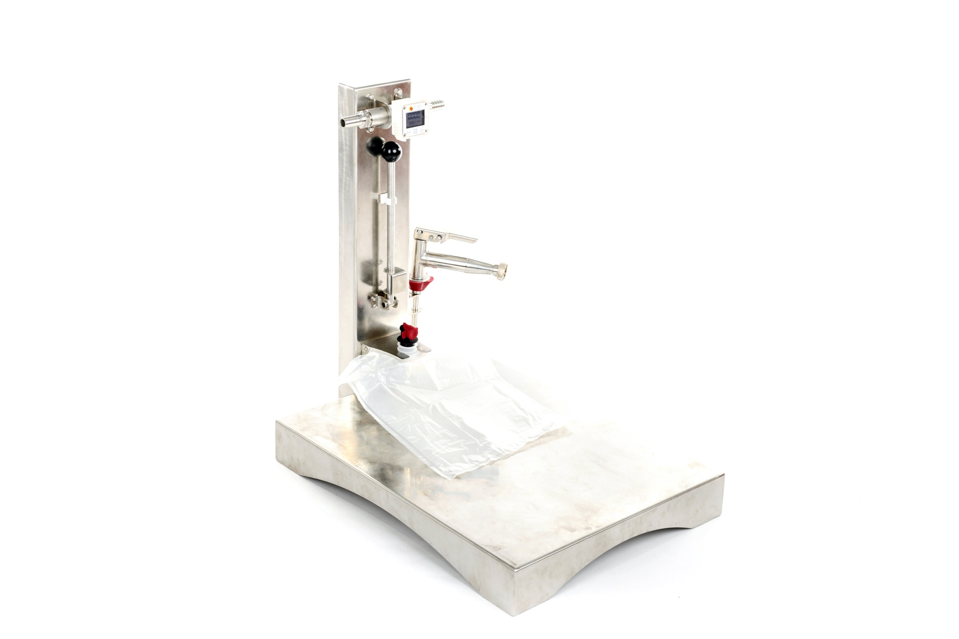

Dear customer!
This manual will help you learn how to use the bag filler effectively.
When buying, check the scope of supply specified in Table 1, the absence of visible and mechanical defects.

ATTENTION!
Please read this manual carefully before using the bag filler.
Due to the continuous improvement of the product, the company reserves the right to make individual changes in its design and appearance, which may cause differences between the purchased product and its description or the image in the figure.

1. General guidance
1.1 The Bag in Box filler BIBF-20 (hereinafter referred to as the "bag filler") is designed for filling 1.5 l, 3 l, 5 l, 10 l, and 20 l bags (Bag-in-Box), as well as for filling glass bottles with juice, wine and other food liquids.
1.2 The bag filler is designed to operate indoors or under shelter at ambient temperatures from 0°C to plus 40 °C.
1.3 Keep the appliance from falling or bumping during operation and storage.

2. Bag in Box filler BIBF-20 - list of equipment and configuration

Component | Quantity (pcs.)
Filling tray | 1
Filling pistol | 1
Digital flowmeter | 1

3. Bag in Box filler BIBF-20 - specification

Filling tray dimensions: | 650х600 mm
Productivity of the flowmeter: | 10-120 l/min
Max Temperature of fluid: | 85 °C
Min Pressure: | 0.3 Bar
Max Pressure: | 15 Bar
Weight: | 20 kg
Dimensions: | 600х650х500 mm
Material: | stainless steel

4. Safety measures
Follow safety measures using this device. Violation of using guidelines and safety measures may lead to accidents.

ATTENTION!
4.1 Use only as intended for filling juice, wine and other food liquids.
4.2 Keep minors under 16 from using the bag filler. Keep the bag filler out of reach of children.
4.3 When working with the bag filler, pay close attention to the safety of persons in the operating area of the appliance.
4.4 Do not use the unit for filling under rain in the open area.
4.5 Under no conditions can the housing of the flowmeter be wet. Make sure that the juice does not make contact with the flowmeter casing.
4.6 Before starting work, install the bag filler in a safe place on a hard and flat surface. It must be positioned in a stable way.
4.7 Be careful using the filler, as there is a danger of getting burned by hot juice, steam or heated filler elements.

5. Preparation for work
5.1 Remove the product from its packaging. The bag filler is disassembled for transportation.
5.2 Place the product on a flat surface, such as a table.
5.3 Connect the filling tray to the second part of the bag filler using the 4 bolts supplied.
5.4 Put a silicone tube of the required length on the output tube of the flowmeter. Connect the second end of the tube with the filling pistol. Fix the tube with stainless steel clamps. The silicone tube should be fit for contact with food and for juice pasteurization temperature.
5.5 Connect the inlet tube of the flowmeter to the juice pasteurizer or another container with the pasteurized juice using a silicone tube. Fix the tube with stainless steel clamps. The silicone tube should be fit for contact with food and for juice pasteurization temperature. The juice container should be placed 0.5-1 m above the bag filler to provide the required fluid pressure.
5.6 An electric pump designed for hot juice can also be used to create the necessary pressure by connecting it between the inlet tube of the flowmeter and the juice container (pasteurizer).
5.7 Insert the filling pistol into the special holder.

6. Operating procedure.
6.1 Install the bag filler in a safe place on a hard and flat surface. The pasteurizer must be positioned in a stable way.
6.2 Pour 10-20 litres of hot drinking water (70-80 °C) into the pasteurizer or the juice container.
6.3 Open the locking tap of the pasteurizer or juice container and let the water flow through the bag filler. This is necessary in order to wash the inner cavities of the tubes, the pump and the flow meter.
6.4 Close the locking tap of the pasteurizer.
6.5 Pour the juice into the pasteurizer. After the pasteurization process is complete, open the locking tap of the pasteurizer and let 10-20 litres of hot juice pass through the bag filler. Make sure that the temperature at the outlet of the filling pistol is within acceptable limits.
6.6 Start filling.
6.7 Use a special holder and lever to fill and seal the Bag in Box bags.
6.8 After the work is complete, pour 10-20 litres of drinking water into the pasteurizer and pass the water through the bag filler.
6.9 Disconnect all tubes from the bag filler.
6.10 Wipe the bag filler with a damp cloth and let it dry.

Watch the video of the bag filler operation on the product page of our website or on our YouTube channel: https://www.youtube.com/channel/UCKFdbuOASzI3aWwq2rgMoBA/videos

Approximate amount of juice:
From the juicy apples, depending on the variety and ripeness, collected from the apple tree: 50-70%
From the apples collected from the ground or stale apples: 20-40%.
Therefore, it is better to make the juice of apples freshly picked from the tree. In this way you will get as much juice as possible with the highest amount of vitamins. You will save more time on washing apples (it may take most of the time, especially if you need to sort them and trim the damaged areas). Moreover, you save the necessary fermentation, natural yeast. It is good if you are going to do wine from the juice. Such juice is much tasty and healthy.

How to store the juice for winter:
- In glass jars;
Squeeze the juice using the press for apples. Pour it into the pan. If the juice is too sour you may add some sugar. Heat it to 70-80 ° C and leave it heating for 5 minutes. Then pour the juice into sterile jars and roll up with sterile lids. Turn the jar upside down and wrap it up. Leave to cool.

- Bag in Box;
It is possible to store the juice using the bag in box system: fill the plastic bag with hot pasteurized juice and place it in a cardboard box.

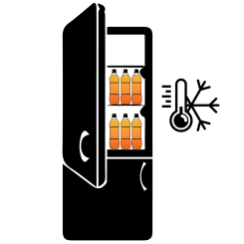
- Freeze;
It is very convenient to freeze the juice in conventional plastic bottles, if the size of your freezer allows it. Just pour the juice into bottles and put them in the freezer. In this case you do not need to spend time on pasteurization; the juice retains 80-90% of vitamins and retains its original taste (as if it is just squeezed). Pasteurized juice has slightly different taste, it changes owing to heating.

More information about juice storage for winter read on our website. There you may also find a variety of apple recipes and useful articles about care of your garden.

7. Maintenance
7.1 If the cutting blade gets blunt, it can be sharpened with a round file or milling metal.

8. Storage rules
Store the crusher in a dry place, avoiding the contact with precipitations and direct sunlight.

9. Manufacturer's warranty
9.1 The manufacturer guarantees good work of the device if the rules of governing storage, installation and operation mentioned in the using guide are observed.
9.2 The warranty period for the device is determined by the manufacturer and it lasts for 36 months from the date of sale to the customer. If the date of purchase is not mentioned, the warranty period is counted from the date when the device was manufactured.
9.3 The manufacturer guarantees free repairs during the warranty period if the following conditions are met:
- the device was used strictly according to the using guide, otherwise the repair is paid by the customer;
- a positive decision of examination carried out by the commission of experts in the quality department within one month from the date of receiving the device back;
- the device was received clean, without any mechanical damage, and fully equipped;
- customer’s application specifying the reasons of breaking down, photos or videos;
- technically justified act of the trading organization.
9.4 The manufacturer's warranty excludes the following cases:
- the origin of a defect in an intentional and mistaken actions of the customer;
- the damage or breaking down of the device owing to natural disasters;
- the damage caused by ingress of extraneous items, objects, liquids;
- the damage caused by the direct or indirect effect of mechanical forces, chemical, thermal or physical coercion;
- disassembly, modification and other interventions which are not provided in the using guide.

Manufacturer:
SIA «Apple Press Ltd»
Registration number: 40203130458
VAT number: LV40203130458
Address: Maskavas iela 260K-1-13, Riga, LV-1063, Latvia

